Selçuk Kanun 34358 DSA 210 Term Project Final Report

Motivation
F1 is among the one the most popular sports around the world and as a fan of this sport I always wondered what metric makes a champion a champion. In this project I will try to investigate metrics that affect championship rates. More specifically, does outperforming your teammate show correlation with being a champion and does being a good driver in wet show correlation with being a champion. I would consider these two since drivers who share the same car could perform similarly and I believe it is the most important metric for a champion to outperform their teammate because basically the drivers who share a team also share a car so they are in equal conditions. Also, wet races always believed to measure the driving ability more so I'd be checking if being better in wet correlates with being a champion furthermore being more champion.

In particular, this project is motivated by three key questions. First, do champions consistently outperform their teammates, suggesting sustained dominance rather than isolated success? Second, does performance under challenging conditions—such as wet-weather races—serve as a distinguishing factor between champions and non-champions? Third, are there drivers who, despite never winning a championship, exhibit statistical profiles similar to those of champions?
To address these questions, the project combines classical statistical analysis with modern machine learning techniques. Hypothesis testing is used to establish whether observed differences between champions and non-champions are statistically significant, while supervised and unsupervised learning methods are employed to explore higher-dimensional performance patterns. By integrating these approaches, the project aims to provide a structured, data-driven perspective on what championship-level performance looks like in Formula 1.

Datasets and Data Enrichment
This project relies on multiple datasets derived from historical Formula 1 race results, each serving a distinct purpose in capturing different dimensions of driver performance. Rather than relying on a single raw dataset, the analysis combines race-level and driver-level information to construct a richer representation of career performance.

The main data set is the Kagel dataset about F1 data from 1950 to 2024 (links are in the readme file). I also derived F1 champions list from 1985 to 2024 and also wet races data both by hand and with the help of other data sets. To enrich it I merged many data from that particular dataset and did feature engineering on the topics like wet race winrate teammate beating rate etc.

Final Dataset
I did some filtering along the way the first one was I only considered races from 1985. It is because F1 is constantly changing and we need to consider the much more modern eras. In the older dates the format was varying much in early years there was no teammates and very few wet races this is why I picked these dates. Also applied limitations of 5 races because it would create much noise for drivers who races for 1 race would meant 100% or 0%.
I collected the number of championships data from wikipedia and cross checked the weather data from the kaggle with simply going over each races that has precipitaion. I checked whether it has affected the particular race or not and then used LLM to cross check it from discussions on Reddit.
Then I merged all the results from results.csv and used the wet race divtionary to tag them as wet races. Then I got "statusId", "status" from status.csv"; got "raceId", "year", "name", "is_true_wet" from results.csv; got "constructorId","name" and merged them all.
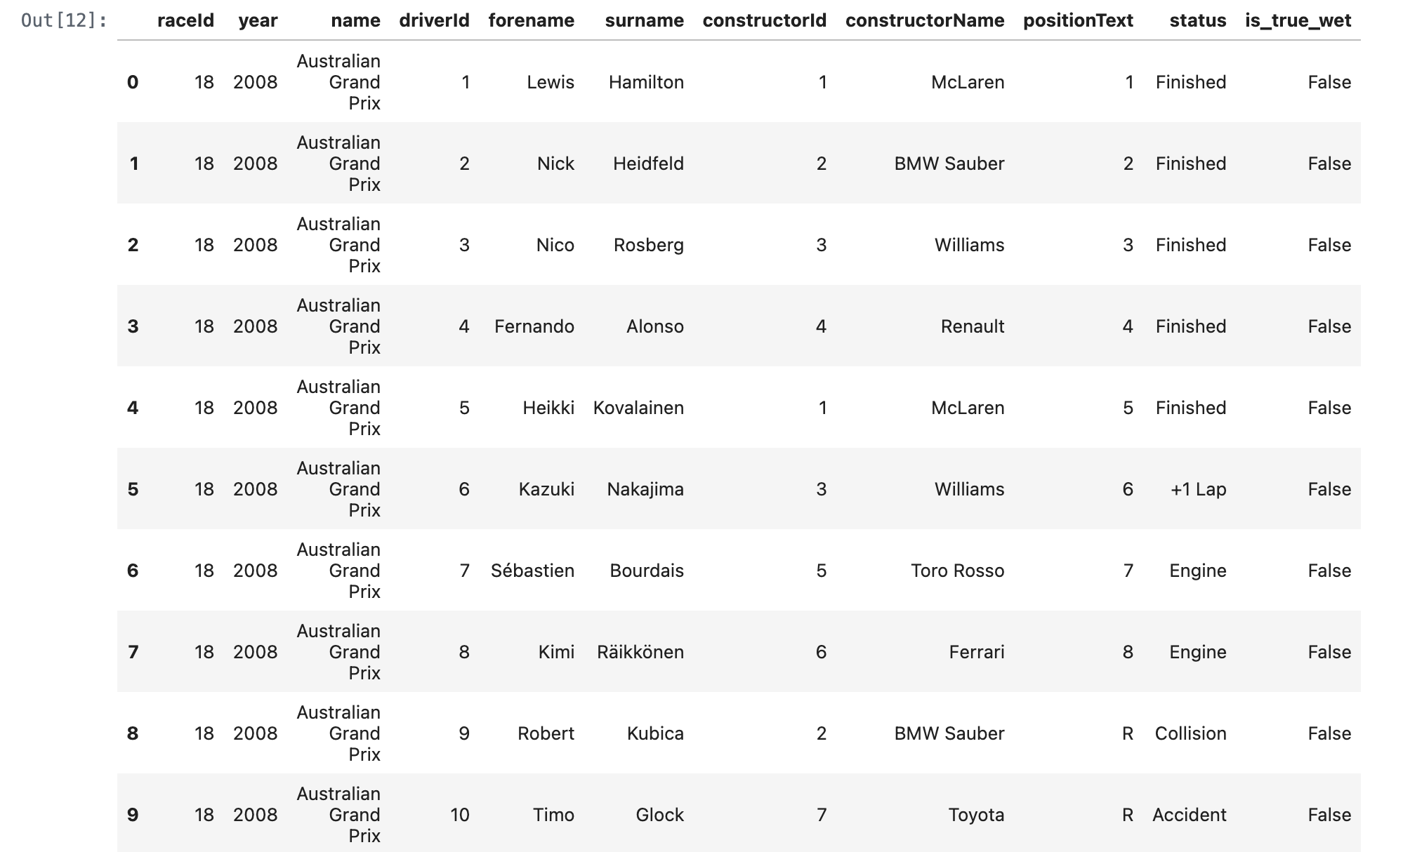

Hypothesis Testing
The hypothesis testing component of this project aims to formally evaluate whether World Drivers’ Champions exhibit systematically different performance compared to non-champions. Rather than relying on descriptive comparisons alone, statistical hypothesis testing is used to assess whether observed differences are unlikely to have arisen by chance.

Research Hypothesis
The primary hypothesis examined in this section concerns relative performance within teams, measured through teammate comparisons. Because teammates compete using comparable machinery, outperforming a teammate provides a meaningful indicator of individual driving performance.
The hypotheses are defined as follows:
- Null Hypothesis (H₀):
Being World Driver Champion (WDC) has no effect on how much they outperform their teammate
- Alternative Hypothesis (H1):
Being WDC means outperforming your teammates more across the career.
- Alternative Hypothesis (H2):
Champion drivers perform better in wet conditions than non-champions, and more championships correlates with more win-rate in wet races.

Methodology
To test these hypothesis I used Spearman Correlation and Mann-Whitney U test

Results
The regression results indicate a statistically significant and positive relationship between championship status and the probability of beating a teammate. The estimated coefficient on the champion indicator is positive and highly significant, with a p-value well below conventional significance levels.
In practical terms, the results suggest that World Drivers’ Champions are substantially more likely to finish ahead of their teammates than non-champions. Predicted probabilities derived from the model show that non-champions beat their teammates in approximately half of their races, while champions do so with a markedly higher probability.
These findings provide strong statistical evidence against the null hypothesis and support the claim that sustained dominance over teammates is a defining characteristic of championship-level drivers.

Interpretation and Limitations
While the hypothesis test establishes a statistically significant association, the results should not be interpreted causally. Championship status is a career-level outcome, and the analysis does not imply that becoming a champion causes improved teammate performance or vice versa. Instead, the results indicate that drivers who become champions tend to exhibit superior relative performance throughout their careers.
Overall, the hypothesis testing results motivate the subsequent use of machine learning methods to explore whether this performance gap persists when multiple performance dimensions are considered simultaneously.

Results of The Hypothesis Testing
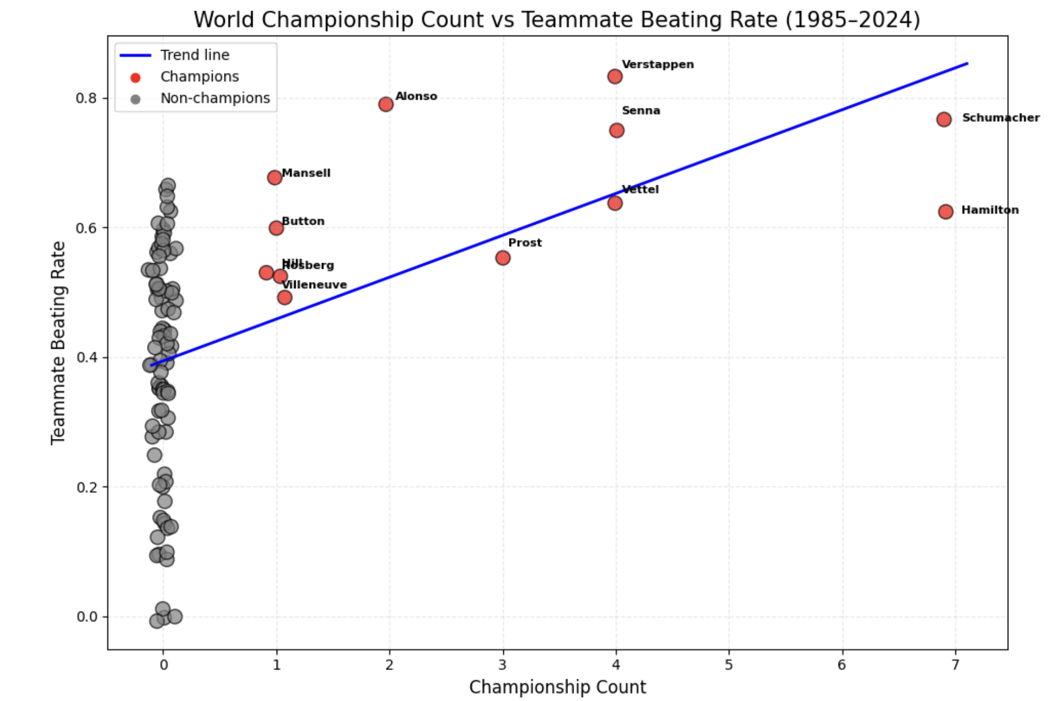

Mann–Whitney U-Test (Beating Rate)
U statistic: 937.5
p-value: 0.000005033

Spearman Correlation
Correlation: 0.4691
p-value: 0.000001102
df = 96

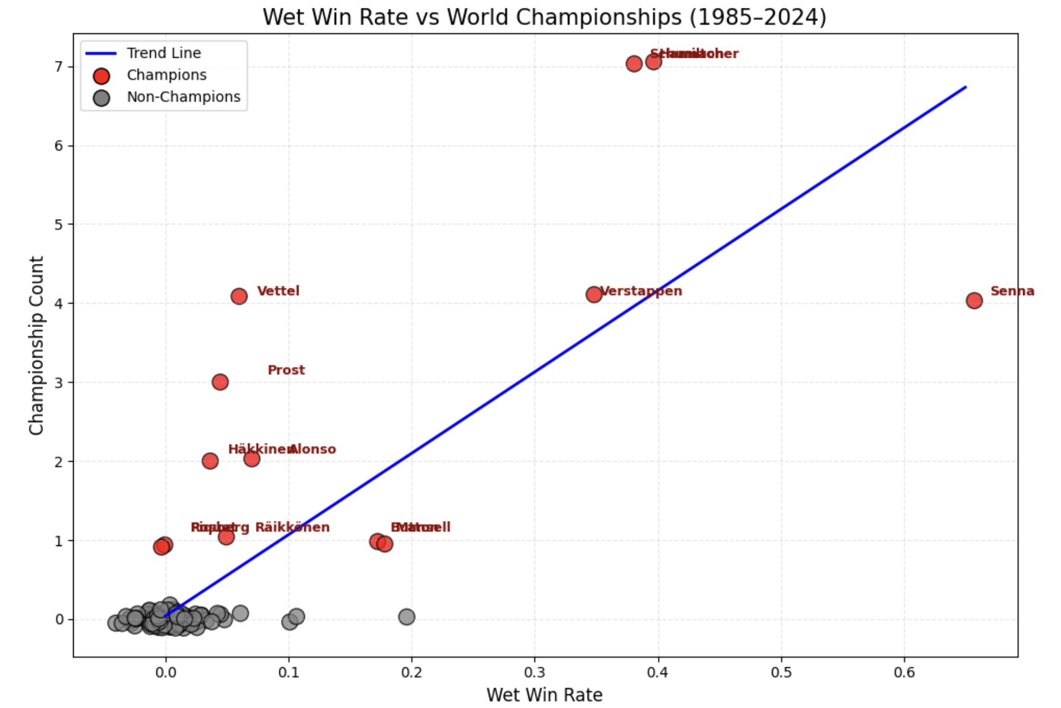

Wet Win Rate vs Championships (Champions Only)
Spearman r = 0.6595, p = 0.0142

Machine Learning Models:

Supervised Learning: Random Forest Classification
A Random Forest classifier is applied to distinguish World Drivers’ Champions from non-champions using a set of engineered performance features. The input features include teammate beating rate, total number of races, wet-weather win rate, and number of wet-weather podium finishes. The target variable is a binary indicator denoting championship status.
The primary objective of the Random Forest model is not prediction accuracy, but rather feature importance analysis. By aggregating decision rules across multiple trees, the model provides a measure of how much each feature contributes to distinguishing champions from non-champions.
To account for the imbalance between champions and non-champions in the dataset, class-weighted training is employed. This ensures that the minority class—champions—receives appropriate emphasis during model fitting.
The resulting feature importance scores indicate that wet-weather performance metrics and teammate beating ratecontribute most strongly to classification, while total race count plays a comparatively smaller role. This suggests that consistent high-level performance, particularly under challenging conditions, is more characteristic of champions than career longevity alone.

Unsupervised Learning: Clustering Driver Profiles
To explore whether drivers naturally group into distinct performance archetypes, unsupervised learning is applied using K-Means clustering. Unlike supervised classification, this approach does not use championship labels during model training. Instead, it relies solely on standardized performance features.
Prior to clustering, all features are standardized to ensure equal weighting and prevent scale-driven dominance. The K-Means algorithm is then used to partition drivers into three clusters, loosely corresponding to high-performing drivers, midfield drivers, and lower-performing drivers.
Visualization of the clusters reveals that World Drivers’ Champions tend to concentrate within a specific region of feature space characterized by high teammate beating rates and strong wet-weather performance. Importantly, several non-champions also appear within this region, indicating that championship-level statistical profiles are not exclusive to drivers who ultimately won a title.
This clustering analysis highlights the existence of champion-like performance archetypes and motivates further investigation into drivers whose careers resemble those of champions despite lacking championship titles.

Probabilistic Classification: Champion-Like Profiles
To quantify how closely individual drivers resemble historical champions, logistic regression is employed to estimate the probability that a driver belongs to the champion class given their performance features. Unlike deterministic classification, logistic regression provides probability estimates that can be interpreted as measures of similarity rather than predictions.
The model is trained using the same set of performance features as the Random Forest classifier. Predicted probabilities are then computed for all drivers, including those who never won a championship.
Drivers with high predicted probabilities but no championship titles are identified as statistical outliers—drivers whose performance profiles closely resemble those of champions. These results reinforce the notion that championship outcomes are influenced not only by individual performance but also by external factors such as team competitiveness, timing, and opportunity.

Results

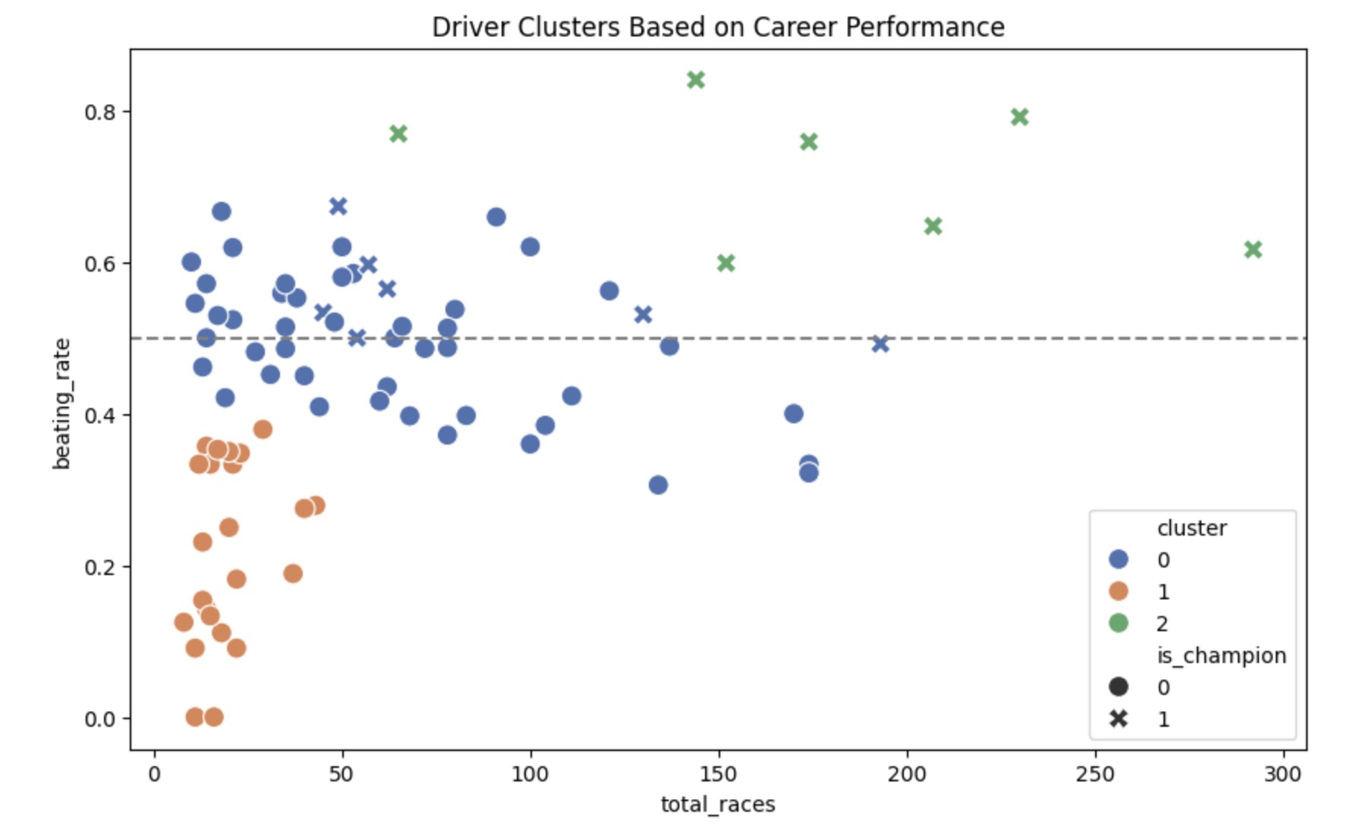

Unsupervised Learning Findings: Driver Clustering
The clustering analysis identifies three distinct driver performance archetypes based on teammate beating rate and career length. The largest cluster contains drivers with moderate beating rates around the 50% threshold across varying career lengths, including most World Drivers’ Champions, who tend to occupy the upper end of this range. This indicates that champions are characterized by consistently strong relative performance rather than longevity alone.
A second cluster consists primarily of drivers with low beating rates and short careers. These drivers rarely become champions, suggesting that early and sustained underperformance relative to teammates limits championship potential.
The third cluster is smaller and dominated by drivers with very high teammate beating rates. Nearly all drivers in this cluster are champions, highlighting extreme teammate dominance as a strong marker of championship-level performance. Notably, a small number of non-champions also appear within champion-dominated regions, suggesting that individual performance alone is not always sufficient to secure a championship.

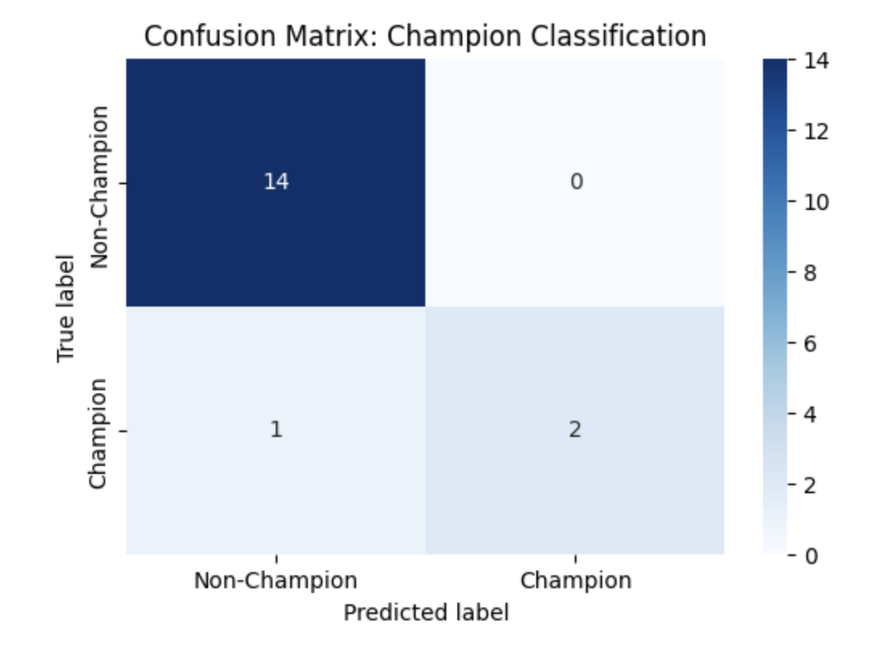

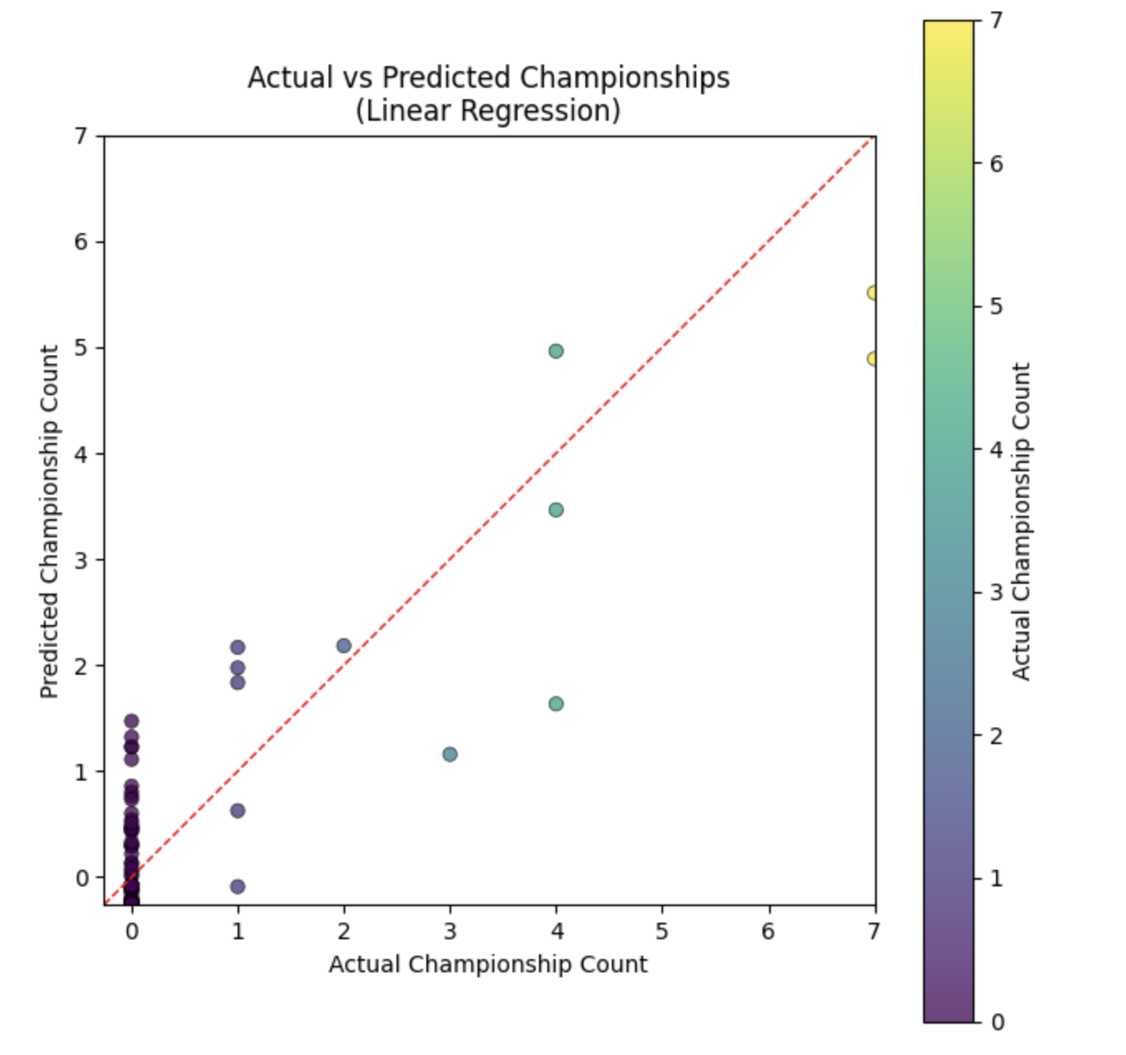

Regression Findings: Actual vs. Predicted Championships
The scatter plot compares the actual number of championships won by each driver with the values predicted by a linear regression model. The dashed diagonal line represents perfect prediction, where predicted and actual championship counts coincide.
The results show that the model captures a general positive relationship between driver performance features and championship count: drivers with more championships tend to receive higher predicted values. However, the predictions exhibit substantial dispersion, particularly for drivers with zero championships, many of whom receive small but positive predicted values.
For drivers with multiple championships, the model often underestimates extreme success, predicting fewer championships than actually achieved. This reflects the difficulty of modeling championship counts using linear regression, as titles are discrete, rare events influenced by factors beyond individual performance.
Overall, the figure illustrates that while performance metrics contain meaningful information about championship success, linear regression is limited in its ability to precisely predict championship totals. This reinforces the project’s emphasis on pattern identification rather than exact prediction and motivates the use of classification and probabilistic approaches elsewhere in the analysis.

Summary
Together, the machine learning methods complement the hypothesis testing results by demonstrating that championship-level performance is multi-dimensional. While teammate dominance and wet-weather performance emerge as key distinguishing features, the presence of non-champions with champion-like profiles underscores the limits of outcome-based evaluations. These findings motivate a broader interpretation of success in Formula 1 that extends beyond championship titles alone.

Limitations and Future Work
While this project provides meaningful insights into the performance characteristics associated with Formula 1 World Drivers’ Champions, several limitations should be acknowledged.
First, the analysis is observational and non-causal. Championship status is treated as a career-level outcome, and the methods employed do not establish causal relationships between performance features and championship success. Instead, the results identify statistical associations and performance patterns that tend to characterize champions.
Second, the use of career-level aggregated statistics may obscure important temporal dynamics. Driver performance evolves over time, and aggregating across entire careers can mask early-career development, peak performance periods, or late-career decline. Future work could address this limitation by adopting a season-level or race-level modeling framework.
Third, the dataset exhibits class imbalance, with a relatively small number of champions compared to non-champions. Although class-weighted models are used to mitigate this issue, imbalance may still influence feature importance estimates and classification boundaries.
Fourth, some performance features—particularly wet-weather metrics—are subject to small sample size constraints. Despite filtering drivers with limited wet-race exposure, estimates of wet-weather performance may still be noisy for certain drivers.
Finally, championship outcomes are influenced by factors not captured in the dataset, including team competitiveness, regulatory changes, strategic decisions, and timing. The presence of non-champions with champion-like statistical profiles highlights the role of opportunity and context beyond individual performance.
Future research could extend this analysis by incorporating season-level data, constructor strength indicators, or causal inference techniques to better disentangle individual ability from external factors. Additionally, alternative modeling approaches such as survival analysis or hierarchical models could provide deeper insight into the pathways leading to championship success.

Usage of LLM’s and other AI’s:
I used ChatGPT and Gemini in many part of the coding part of the project. I also heavily used it in the selection of the which ML model to use and used it at explaining some concepts more clearly. I also utilized AI in terms of grammar and writing of some parts of this final report. All prompts are within my ChatGPT and Gemini account and could be shared if needed.

